# AI ASSIGNMENT 3

(Rapid-miner Tasks' Report)

Eisha Tir Raazia

17K-3730

Section C

**Q1:**

**Coding Task**

**Q2:**

**Naïve Bayes model on 'Wine Data Set'.**

a) Split dataset for training and testing in the ratio of 70:30 for training and testing respectively.

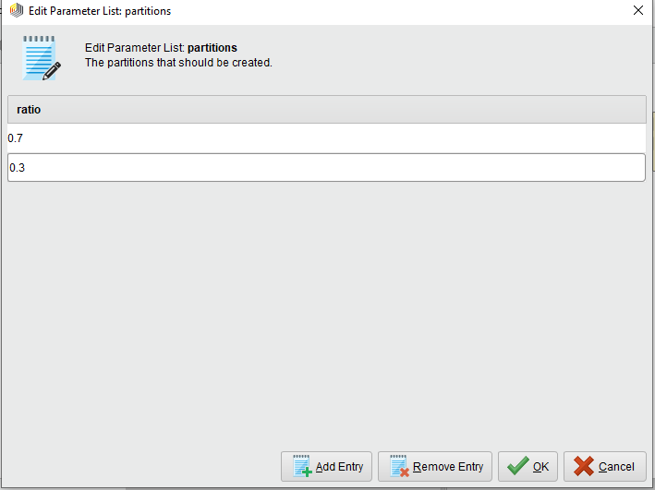

b) Create the model for training and testing data and then classify

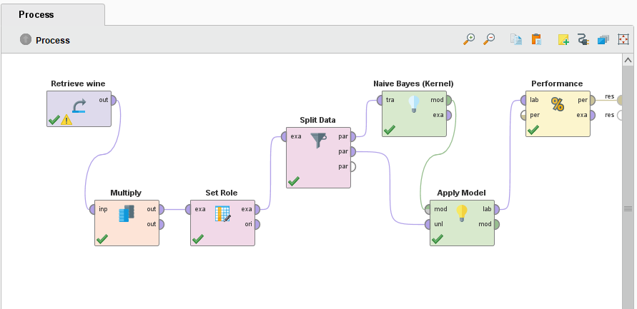

c) Performance parameters i.e. accuracy, precision and recall to show how much accurate the model has been for the dataset.

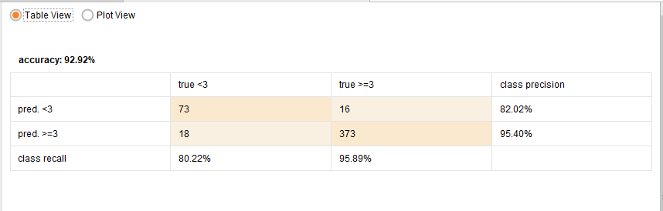

And,

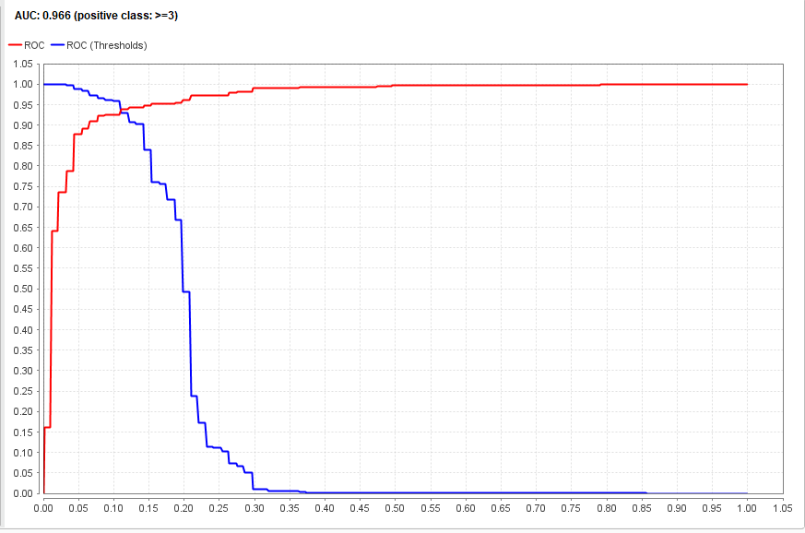

**Naïve Bayes(kernel) model on 'Wine Data Set'.**

a) Split dataset for training and testing in the ratio of 70:30 for training and testing respectively.



b) Create the model for training and testing data and then classify .



c) Performance parameters i.e. accuracy, precision and recall to show how much accurate the model has been for the dataset.

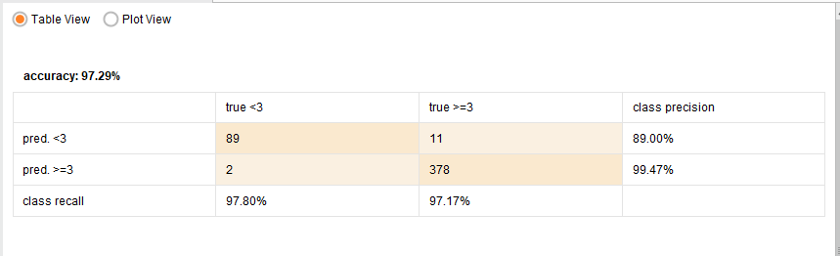

And,

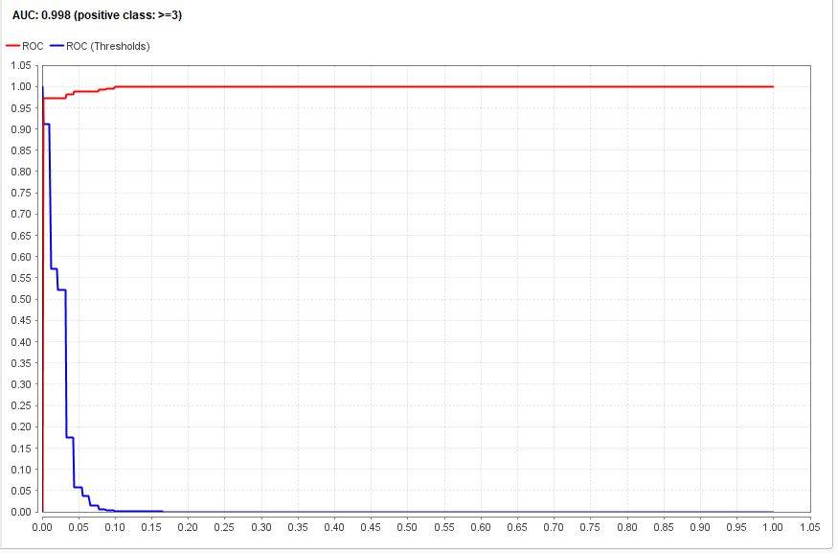

**Q3:**

**Naïve Bayes model on 'PD Data Set'.**

a) Converts this numerical class label values into nominal ones.

b) Train naïve bayes model using the training dataset.

c) Repeat (part a) on Parkinson testing dataset.

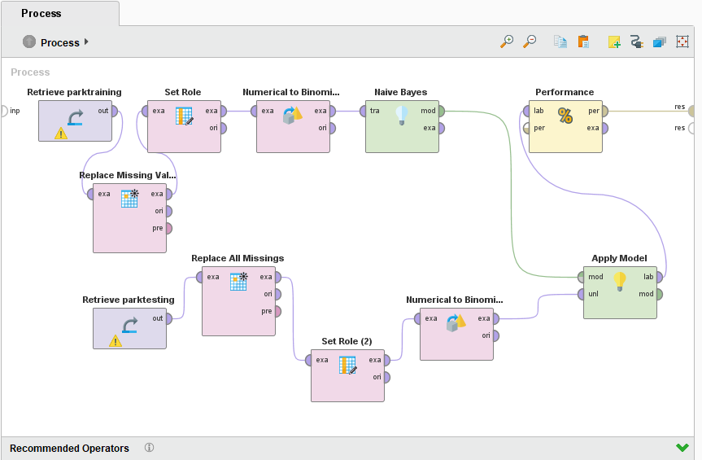

c) Performance parameters i.e. accuracy, precision and recall to show how much accurate the model has been for the dataset.

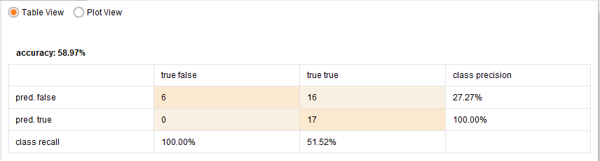

And,

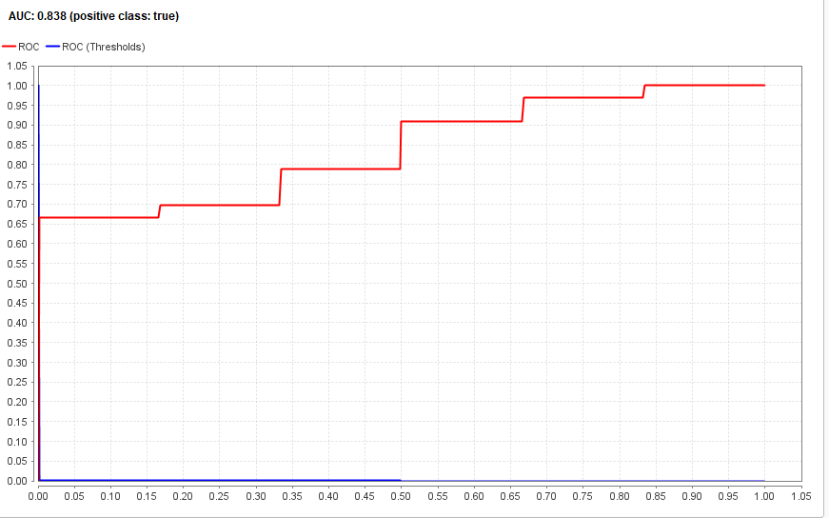

**e) Naïve Bayes(kernel) model on 'PD Data Set'.**

a) Converts this numerical class label values into nominal ones.

b) Train naïve bayes model using the training dataset.

c) Repeat (part a) on Parkinson testing dataset.

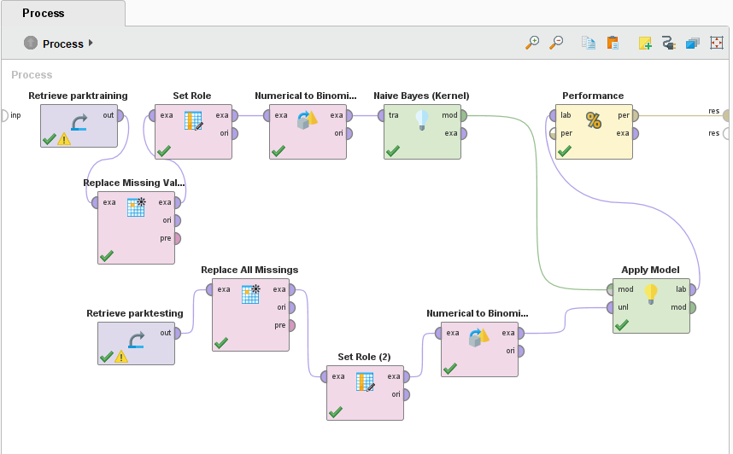

c) Performance parameters i.e. accuracy, precision and recall to show how much accurate the model has been for the dataset.

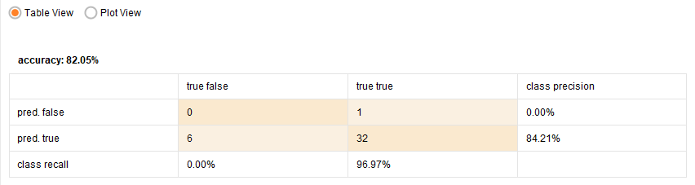

And,

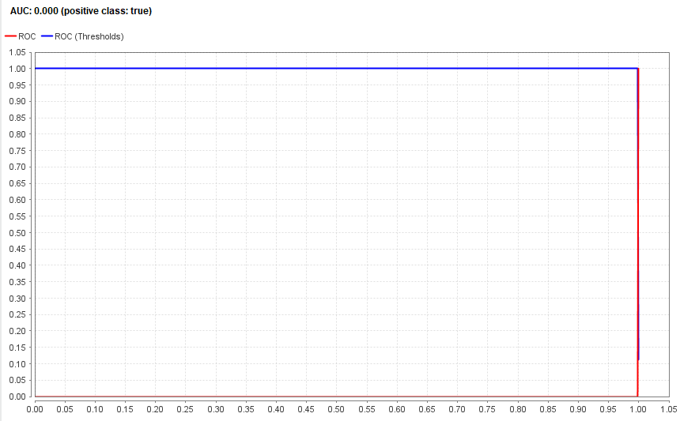

**Q4:**

**K-mean Clustering on 'Wine Data Set'.**

a) Drop 'citric' attribute, from the dataset.

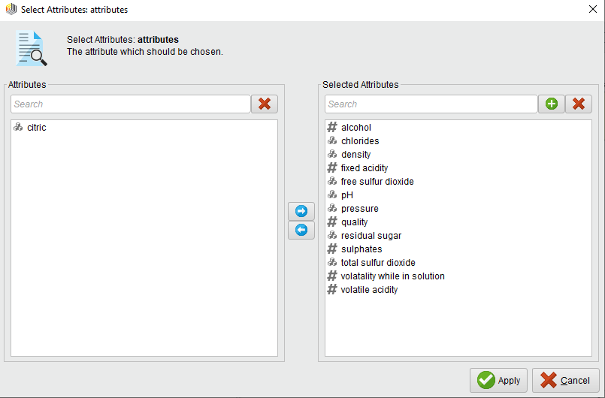

b) Apply k-means clustering and then compare the results of clusters

**K=2**

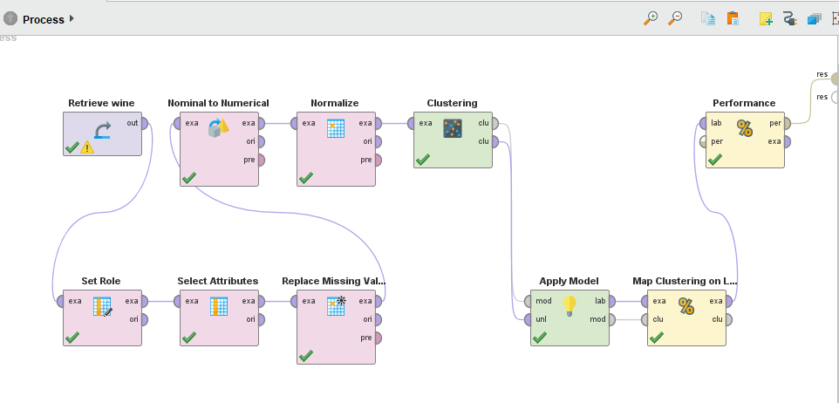

c) Check performance of the model

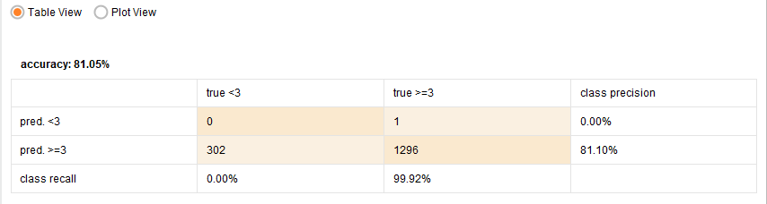

And,

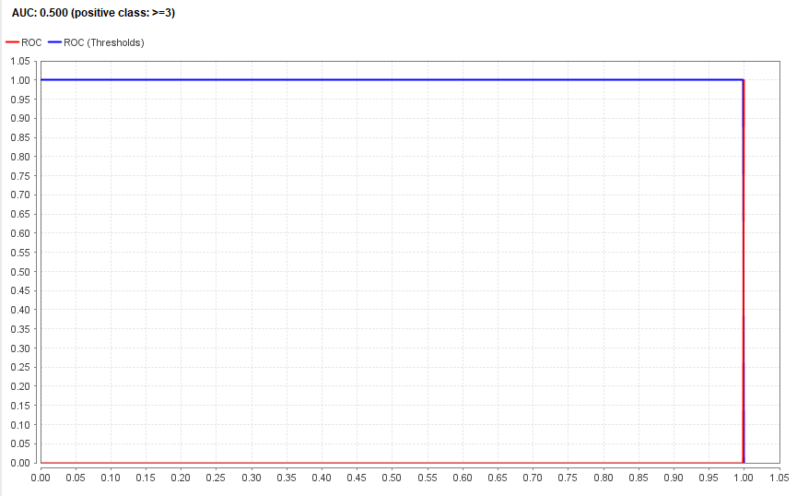

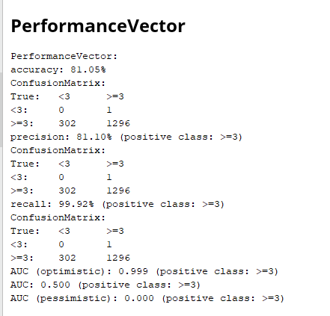

----------------------------------xx------------------------------------